Single Sign-On (SSO) - OIDC

Introduction:

Pickup is a cab company that has many employees and different internal enterprise applications. Following are two such applications:
- Pickup Dispatch: This application helps manage the overall operations at Pickup.
- Pickup Manager: This application helps allocate vehicles to drivers.
Pickup is using WSO2 Identity Server as the identity provider for their applications.
Bob is a Pickup employee who usually forgets application passwords. As a result, Bob uses the same credentials for all the Pickup applications. However, due to busy schedules, Bob does not like entering the credentials at every login. So, the WSO2 Identity Server team suggested Bob to use Single Sign-On (SSO).
With SSO, Bob only needs to provide the login credentials to one Pickup application and automatically be logged in to other Pickup applications.
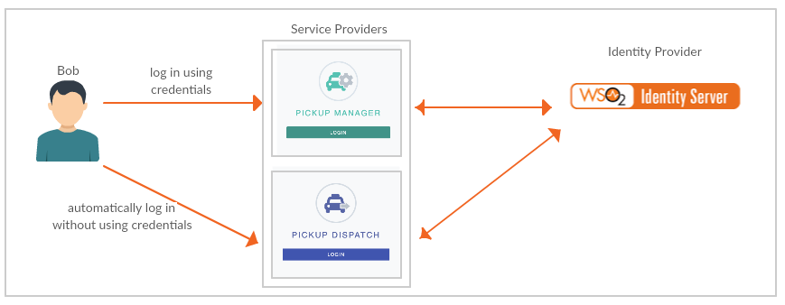
This tutorial will allow you to have hands-on experience on how to configure SSO with WSO2 Identity Server using OIDC protocol.

Setting up:
- Set up Apache Tomcat 9:
  - Extract the Apache Tomcat 9 zip. The extracted folder is called <TOMCAT_HOME> below.
  - Make sure the JAVA_HOME environment variable points to your JDK (21 or 25).
  - Start Tomcat from <TOMCAT_HOME>/bin. It listens on port 8080:
Windows (Command Prompt):
cd <TOMCAT_HOME>\bin
catalina.bat start
Linux / macOS (Terminal):
cd <TOMCAT_HOME>/bin
sh catalina.sh start
  - Open http://localhost:8080 and check that the Tomcat page loads. To stop Tomcat, run catalina.bat stop (Windows) or sh catalina.sh stop (Linux/macOS) from the same folder.
- Get pickup-dispatch.war and pickup-manager.war from the SampleApps folder provided with this training. These versions already contain the WSO2 Identity Server 7.3.0 keystore (wso2carbon.p12), so you do not need to copy the keystore from the WSO2 IS pack.
Note: If you use older versions of these samples from GitHub instead, change localhost.com to localhost in dispatch.properties and manager.properties, copy <IS_HOME>/repository/resources/security/wso2carbon.p12 to WEB-INF/classes/ of each web app, and add enable_admin_services = true under [server] in <IS_HOME>/repository/conf/deployment.toml (then restart WSO2 Identity Server).
- Copy both WAR files into <TOMCAT_HOME>/webapps. Tomcat deploys them automatically and creates the pickup-dispatch and pickup-manager folders.

Configure Service Providers
- Login to the WSO2 Identity Server Console, using your admin credentials (e.g. admin:admin).
- In the WSO2 Identity Server Console, from the menu click Applications.
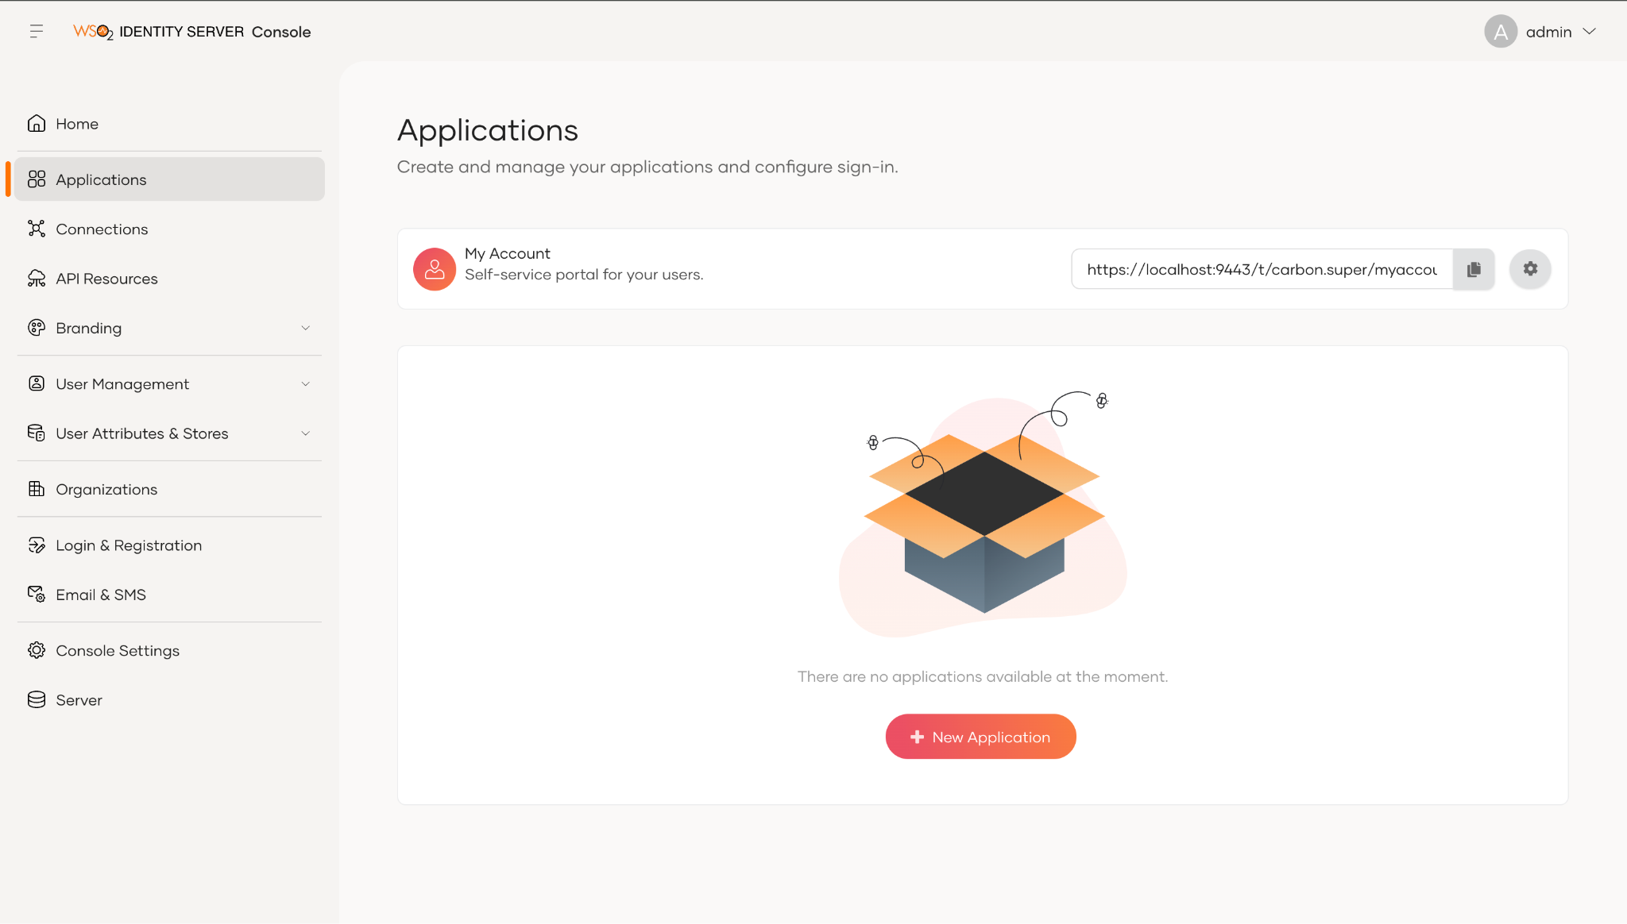
- Click New Application.
- From the given set of templates select Traditional Web Application template.
- Fill the fields in the create application wizard.
Name: Dispatch
Protocol: OpenID Connect
Authorized redirect URLs: http://localhost:8080/pickup-dispatch/oauth2client
Note:
The callback URL is the Application’s URL to which the authorization codes are sent. Upon successful authentication, the browser should be redirected to this URL.

- Click Create and note the Client ID and Client Secret created.

- Similarly, create a service provider for the Pickup Manager application with the following:
Name: Manager
Protocol: OpenID Connect
Authorized redirect URLs: http://localhost:8080/pickup-manager/oauth2client

- Edit the consumerKey and consumerSecret fields in dispatch.properties file in <TOMCAT_HOME>/webapps/pickup-dispatch/WEB-INF/classes with the copied Client ID and Client Secret in step 7 above.

Verify the below properties are in order.
consumerKey=<ClientID>
consumerSecret=<ClientSecret>

callBackUrl=<Assertion_consumer_URL>
authzGrantType=code
scope=openid internal_application_mgt_view

enableOIDCSessionManagement=false
enableOIDCBackchannelLogout=true
authzEndpoint=https://localhost:9443/oauth2/authorize
OIDC_LOGOUT_ENDPOINT=https://localhost:9443/oidc/logout
sessionIFrameEndpoint=https://localhost:9443/oidc/checksession
tokenEndpoint=https://localhost:9443/oauth2/token
claimManagementEndpoint=https://localhost:9443/services/ClaimMetadataManagementService
post_logout_redirect_uri=<Assertion consumer URL>
api_endpoint=http://localhost:39090/bookings
adminUsername=admin
adminPassword=admin
- Similarly edit the consumerKey and consumerSecret fields in manager.properties file in <TOMCAT_HOME>/webapps/pickup-manager/WEB-INF/classes with the copied Client ID and Client Secret in step 8 above.

- Restart Tomcat: in <TOMCAT_HOME>/bin run catalina.bat stop and then catalina.bat start on Windows, or sh catalina.sh stop and then sh catalina.sh start on Linux and macOS.

Try It:

Follow the steps below to try out the sample applications:

- To access the Pickup Dispatch application, go to the following URL.
http://<TOMCAT_HOST>:<TOMCAT:PORT>/pickup-dispatch
ex: http://localhost:8080/pickup-dispatch
- Sign in using Tommy’s credentials.
- To access the Pickup Manager application, go to the following URL.
http://<TOMCAT_HOST>:<TOMCAT_PORT>/pickup-manager
e.g.,: http://localhost:8080/pickup-manager
- Note that Tommy will be automatically logged in to the Pickup Manager application.

You have successfully configured OIDC-based SSO using WSO2 Identity Server as the identity provider.

